Answers from the Commission and European Court

(Comment; the following extracts are from official judgments/documents/replies from Europe of relevance to current issues affecting Scottish ferry services. Minimal comment is added to them).

EXTRACT 1
from Council Regulation (EEC) No 3577/92 of 7 December 1992 applying the principle of freedom to provide sevices to maritime transport within Member States (maritime cabotage)
From Article 2…
3. 'a public service contract' shall mean a contract concluded between the competent authorities of a Member State and a Community shipowner in order to provide the public with adequate transport services. A public service contract may cover notably: - transport services satisfying fixed standards of continuity, regularity, capacity and quality, - additional transport services, - transport services at specified rates and subject to specified conditions, in particular for certain categories of passengers or on certain routes, - adjustments of services to actual requirements;
4. 'public service obligations' shall mean obligations which the Community shipowner in question, if he were considering his own commercial interest, would not assume or would not assume to the same extent or under the same conditions;
…….
Article 4
1. A Member State may conclude public service contracts with or impose public service obligations as a condition for the provision of cabotage services, on shipping companies participating in regular services to, from and between islands. Whenever a Member State concludes public service contracts or imposes public service obligations, it shall do so on a non-discriminatory basis in respect of all Community shipowners.
2. In imposing public service obligations, Member States shall be limited to requirements concerning ports to be served, regularity, continuity, frequency, capacity to provide the service, rates to be charged and manning of the vessel. Where applicable, any compensation for public service obligations must be available to all Community shipowners.
3. Existing public service contracts may remain in force up to the expiry date of the relevant contract.

END

EXTRACT 2

WRITTEN QUESTION P-3802/06
by Alyn Smith (Verts/ALE)
to the Commission

Subject: Public service obligations in connection with EC ferry services

Can the European Commission state whether defined public service obligations are required in order to subsidise EC ferry services and ensure compliance with Regulation (EEC) No 3577/92 and EC state aid law?

P-3802/06EN
Answer given by Mr Barrot
on behalf of the Commission
(6.10.2006)

Council Regulation (EEC) No 3577/92 of 7 December 1992 applying the principle of freedom to provide services to maritime transport within Member States (maritime cabotage) allows Member States to impose public service obligations on all operators on a given route to ensure sufficient service on that route where it appears that, if they considered their own commercial interest, operators would not propose an adequate level of services. These obligations may be imposed by regulation or, if this does not suffice to meet essential transport needs in an adequate manner, laid down by way of public service contracts. If necessary, financial compensation may be granted to operators to cover the costs involved in meeting public service obligations.

The imposition of public service obligations is therefore a precondition for any compensation being given.

Such compensation does not constitute State aid if complies with the criteria laid down by the Court of Justice in its judgment in Altmark.

END

EXTRACT 3

E-3818/06EN
From answer given by Mr Barrot
on behalf of the Commission
(10.1.2007)

It is for Member States (or their competent local authorities) to define public services and to choose the appropriate legal instruments to ensure the provision of such services, provided that the definition of such services and the design of such instruments comply with EC law. In particular, such services shall respond to a need not already satisfied spontaneously by the market, and such instruments shall be transparent, non discriminatory, and comply with the state aid provisions of the EC Treaty and with the relevant sectoral legislation (in this case, in particular, the regulation on maritime cabotage and its interpreting communication). The Commission, therefore, does not insist on the use of one or another specific instrument (PSC or PSO) but will check that any measure taken complies with EC law.

If the competent authority chooses a public service contract, awarded in the present case after a public tender, this contract can foresee a subsidy compensating for the cost of such services. If this subsidy complies with the four criteria laid down by the Court of Justice in its judgment in the case of Altmark Trans GmbH, then this subsidy would not constitute state aid. If this is not the case, this subsidy could be considered by the Commission to constitute compatible state aid if it complies with the applicable legislation and principles, as recalled in particular in the Commission Decision 2005/842/EC of 28 November 2005 or in the Community Framework for state aid in the form of public service compensation. In any case, the subsidy would have to be limited to the compensation of the public service costs, transparent and based on a clear pre-existing definition of the services.

END

EXTRACT 4

E- 4362/06EN
From answer given by Mr Barrot
on behalf of the Commission
(21.11.2006)

The Commission is not aware of the so called "Road Equivalent Tariff" as described by the Honourable Member.

In any case it belongs at first to the operators providing the service and eventually to the public authorities in the framework of public service obligations or public service contract, to define the pricing of a maritime cabotage service.

In the case where the Road Equivalent Tariff would be used as a basis to determine the prices by public service obligations or in a public service contract, the provisions of Council Regulation (EEC) No 3577/92 related to such obligations or contract would be applicable.
The Community rules on state aid would also apply to eventual compensation.

END

EXTRACT 5

EUROPEAN COURT RULING

(Comment; The European Court ruled in February 2001 that in the case of maritime cabotage)

The Commission considers that, in principle, there is nothing to prevent a Member State from deciding to impose public service obligations generally and from concluding a public service contract in respect of one or more lines subject to those obligations in order to ensure an adequate level of service

……………………………………………………

In the light of the features of the two methods in question (PSO and PSC) and their shared purpose, there is no reason why they should not be used concurrently in respect of one line or transport route in order to ensure a certain level of public service. For the reasons given by the Advocate General in points 109 to 111 of his Opinion, where the level of service attained, even after public service obligations have been imposed on the shipowners, is not regarded as adequate or where there are still specific gaps, complementary services could be provided by concluding a public service contract, as laid down in the Spanish legislation.
……………………………………………………
Article 4(1) of Regulation No 3577/92 is to be interpreted as permitting a Member State to impose public service obligations on some shipping companies and, at the same time, to conclude public service contracts within the meaning of Article 2(3) of the regulation with others for the same line or route in order to ensure the same regular traffic to, from or between islands, provided that a real public service need can be demonstrated and in so far as that application of the two methods concurrently is on a non-discriminatory basis and is justified in relation to the public-interest objective pursued.

END
EXTRACT 6

52003DC0595
From Communication from the Commission to the European Parliament, the Council, the European Economic and Social Committee and the Committee of the Regions on the interpretation of Council Regulation (EEC) No 3577/92 applying the principle of freedom to provide services to maritime transport within Member States (maritime cabotage) /* COM/2003/0595 final */

(Comment: section 5.1 makes Gourock-Dunoon and Tarbert-Portavadie eligible to be treated as public service routes to which PSOs can be applied. See also footnote 10 and implications for such agreements as a “Users Charter” proposed by an operator)

5. Public service
The maritime transport of passengers and goods is vital for the inhabitants of Europe's islands. That is why a special set of rules was drawn up to protect some of these maritime links not adequately served by the market.
The Regulation offers Member States a framework to organise in a compatible way market intervention through restrictions on market access or funding relating to public service obligations on maritime services. The purpose of this Section is to further clarify, where necessary, the conditions laid down by the Regulation with the objective of rendering public intervention compatible with general Treaty rules.
5.1. Geographical scope of public service links
According to the wording of Article 4(1) of the Regulation, public service links have to serve routes to, from and between islands. Long estuaries or fjords which lead to a detour of about 100 km by road may be treated as islands for the purposes of this section as they may cause a similar problem by isolating conurbations from each other.
5.2. Island cabotage routes on which public service obligations may be imposed
It is for the Member States (including regional and local authorities where appropriate) to determine which routes require public service obligations. In particular, public service obligations may be envisaged for regular (scheduled) island cabotage services in the event of market failure to provide adequate services.
According to the conditions laid down by the Regulation, Member States may impose public service obligations in order to "ensure the adequacy" of regular maritime transport services to a given island (or in relation to an estuary), where Community shipowners, if they were considering their own commercial interest, would not provide services of an adequate level or under the same conditions. Trade should otherwise remain free.
When imposing public service obligations for services described in Article 4(1) of the Regulation, Member States must limit their intervention to the essential requirements referred to in Article 4(2) and fulfil the requirement of non-discrimination as laid down by Article 4(1) of the Regulation in respect of all Community shipowners interested in serving the route. This requirement must be strictly observed when deciding on the content of the obligations to be fulfilled and during the administrative procedure resulting in the selection of an operator of a given service or establishing the amount of compensation.
5.3. The obligations that may be imposed
5.3.1. The distinction between public service obligations and public service contracts
A distinction is made in Regulation (EEC) No 3577/92 between "public service obligations" (see Article 2(4) and Article 4(2) of the Regulation) and "public service contracts" (see Article 2(3)). Public service contracts are the instrument normally used to enshrine public service obligations where a horizontal approach applying to all shipowners intending to serve a given route may not be sufficient to meet the essential transport needs, in particular general conditions concerning the quality of a given service.
Article 4(2) of the Regulation sets out an exhaustive list of requirements that may be introduced when "public service obligations" are imposed. Article 2(3) of the Regulation provides only an indication of the scope of public service contracts; Member States may go further. In practice, quality requirements are often part of "public service contracts", but cannot be introduced as part of "public service obligations". With regard to "public service obligations", the requirement relating to the shipowners' "capacity to provide the service" may include an obligation related to their solvency as well as the requirement that they have no outstanding tax and social security debts. The Commission takes the view that the obligation to use a fast ferry may also fall within this category.
When public service obligations are imposed, the requirements relating to the regularity and frequency of the service may be met collectively - and not individually - by all the shipowners serving the same route.
END
EXTRACT 7
Reply from Commission (provided by E-mail from Alyn Smith MEP’s office September 2007) to a series of questions posed to the Commission by Alyn Smith March 2007

"for the purpose of applying Council Regulation 3577/92, the crossings between Gourock and Dunoon town centres and between McInroy's Point and Hunter's Quay can be considered as two separate routes and thus treated separately. In particular, the local authorities can impose public service obligations for the carriage of pedestrians on only one of these routes. Compensation may be provided for the public service obligations, subject to compliance with Community rules, in particular to the principle of non-discrimination laid down by Regulation 3577/92. Operators may use their vessels for the "pedestrian service" as well as for the "vehicle service", however any undue distortion of competition, particularly through cross subsidies between the public service activity and other activities should be avoided. As such, any subsidy for the public service activity cannot exceed what is necessary to cover all or part of the costs incurred in the discharge of the public service obligation, taking into account the relevant receipts and a reasonable profit for discharging those obligations".

END

EXTRACT 8
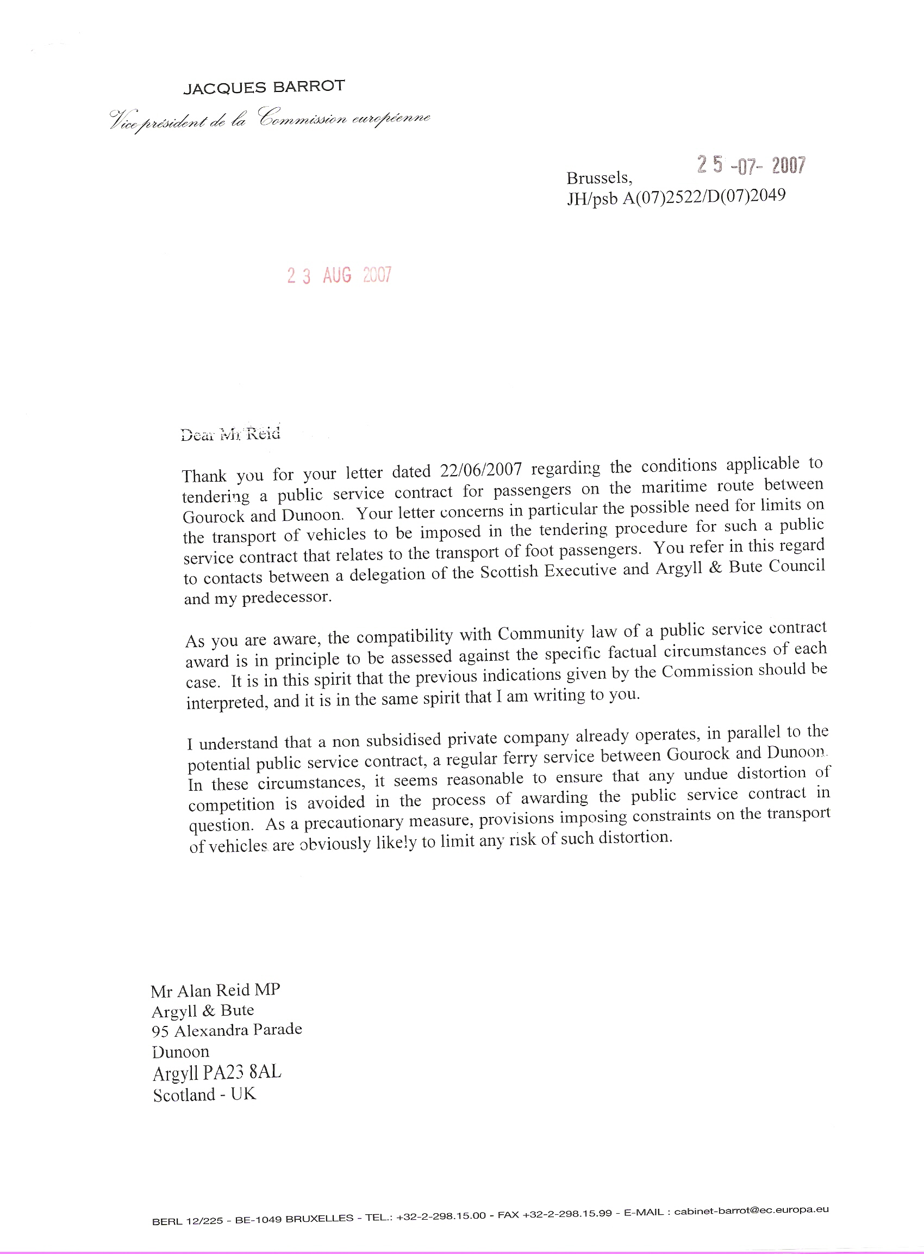
[‘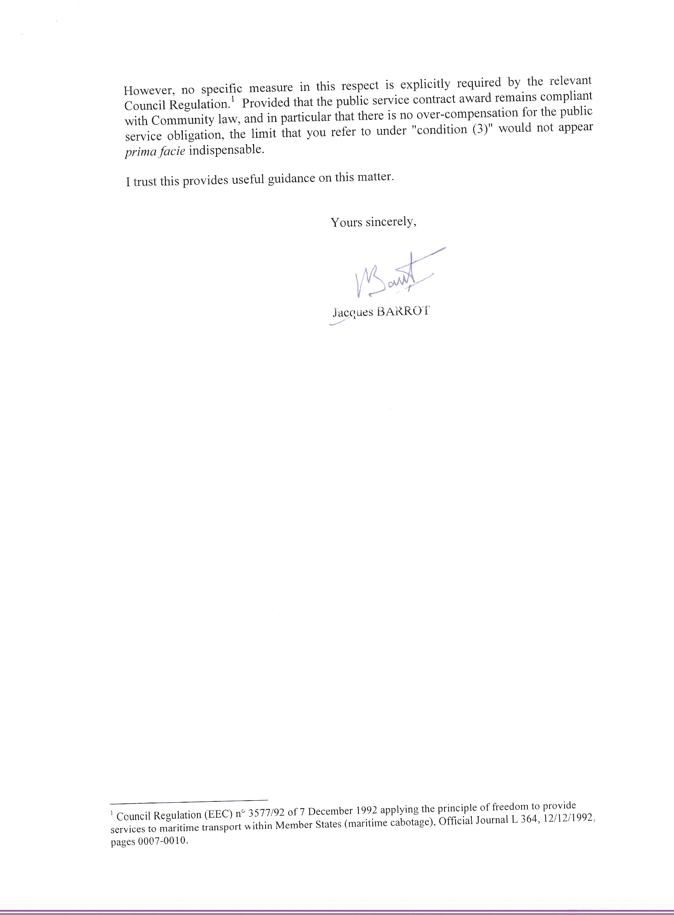
EXTRACT 9

The Altmark Conditions

Following is from the JUDGMENT OF THE COURT of 24 July 2003 in Case C-280/00 (Reference for a preliminary ruling from the Bundesverwaltungsgericht): Altmark Trans GmbH, Regierungspräsidium Magdeburg v Nahverkehrsgesellschaft Altmark GmbH (1)

The condition for the application of Article 92(1) of the EC Treaty (now, after amendment, Article 87(1) EC) that the aid must be such as to affect trade between Member States does not depend on the local or regional character of the transport services supplied or on the scale of the field of activity concerned. However, public subsidies intended to enable the operation of urban, suburban or regional scheduled transport services are not caught by that provision where such subsidies are to be regarded as compensation for the services provided by the recipient undertakings in order to discharge public service obligations. For the purpose of applying that criterion, it is for the national court to ascertain that the following conditions are satisfied:

- first, the recipient undertaking is actually required to discharge public service obligations and those obligations have been clearly defined;

- second, the parameters on the basis of which the compensation is calculated have been established beforehand in an objective and transparent manner;

- third, the compensation does not exceed what is necessary to cover all or part of the costs incurred in discharging the public service obligations, taking into account the relevant receipts and a reasonable profit for discharging those obligations;

- fourth, where the undertaking which is to discharge public service obligations is not chosen in a public procurement procedure, the level of compensation needed has been determined on the basis of an analysis of the costs which a typical undertaking, well run and adequately provided with means of transport so as to be able to meet the necessary public service requirements, would have incurred in discharging those obligations, taking into account the relevant receipts and a reasonable profit for discharging the obligations.

END OF DOCUMENT

OJ L 364, 12.12.1992, p. 7.
OJ L 364, 12.12.1992.
Case C-280/00 [2003] ECR I-7747.
2005/842/EC: Commission Decision of 28 November 2005 on the application of Article 86(2) of the EC Treaty to State aid in the form of public service compensation granted to certain undertakings entrusted with the operation of services of general economic interest , OJ L (2005) 312
OJ C (2005) 297
Council Regulation (EEC) No 3577/92 of 7 December 1992 applying the principle of freedom to provide services to maritime transport within Member States (maritime cabotage), OJ L 364, 12.12.1992.
Asociación Profesional de Empresas Navieras de Líneas Regulares (Analir) and Others v Administración General del Estad: Judgment of the European Court, February 21st 2001 Case C-205/99
Ibid para 59
Ibid, section 66
It is not for shipowners to set public service obligations.
See Recital 9 and Article 2(4) of the Regulation. See also the judgement in Case C-205/99 (reference to the Court under Article 234 of the Treaty by the Tribunal Supremo, Spain, for a preliminary ruling in the proceedings pending before that Court between Asociación Profesional de Empresas Navieras de Líneas Regulares (Analir) and others and Administración General del Estado), paragraphs 31 et seq., [2001] ECR I-1271.
Case C-205/99, cited above, paragraphs 45 to 51.
If an island needs to be served 4 times a week and two shipowners are willing to participate in the trade, each of them should only commit itself to operating twice a week or, respectively, once and three times a week.

